**Summary**

A learning website designed for children aged between 6-10 years old, delving on teaching essential security concepts in an engaging and a manner that is age-appropriate. A wide range of topics have been covered to enable the children navigate the internet responsibly.

**Lessons**

**1.Online Safety Basics:** This lesson covers important practices like strong passwords, handling messages from strangers, and safety tips on how to share information online.

**2.Cyberbullying Awareness:** In this lesson, children are educated on how to recognize, prevent, and respond to cyberbullying, how to support friends, and promoting kindness.

**3.Privacy Protection:** This lesson dives into the guidelines for keeping personal information private, managing privacy settings, and safe social media use.

**4.Safe Social Media Practices:** This lesson teaches children how to maintain privacy and positive interaction on social media platforms.

**5.Safe Searching:** This lesson entails using kid friendly search engines, enabling safe search settings, and recognizing safe websites.

**6.Device Security:** This lesson is about protecting devices with antivirus software, regular updates, and secure access measures.

**7.Understanding Malware and Viruses:** In this lesson, kids are taught about the different types of malware, how to prevent them, and the necessary steps to take in case a device is affected.

**8.Gaming Safety:** Promoting a safe and positive gaming experience by protecting personal information and choosing age appropriate games.

**9.Identifying Phishing Scams:** In this lesson, the children are taught how to recognize and avoid phishing attempts, how to handle suspicious emails, and verifying secure websites.

**10.Undersyanding Digital Footprints:** It involves recognizing the trail of data and personal information left behind while using the internet and digital devices. The young learners are taught the importance of being mindful about their online activities and the long-term impact of their digital presence.

**Features**

**Interactive Quizzes:** The website contains a take quiz button that enables the student to take quizzes to reinforce their understanding.

**Quiz Rules:** Clear rules are provided to ensure a fair and structured testing environment.

**Educational Content:** Detailed notes are provided for each topic with detailed notes and interactive pictures to engage young learners.

**User Experience**

Kid-Friendly Design: A colorful and intuitive design to make navigation easier and enjoyable for children.

**Usability and User Design Goals**

**1.Intuitive Navigation**: To create an easy navigation with a clear and logical structure.

**2.Child Friendly Interface:** To design an interface with bright colors, engaging graphics, and readable fonts.

**3.Consistent design:** To maintain a consistent design and layout across all pages providing a predictable user experience.

**4.Engaging Content:** To provide an immediate feedback on quizzes to reinforce learning.

**5.Clear Instruction:** To offer a step by step instructions for all the quizzes.

**6.Responsive Design:** To ensure that the website is fully responsive and adaptive on various devices, including phones and tablets.

**Usability Question**

**1.Intuitive Navigation:**

How easy is it for children to navigate this website?

Are the menus clearly labelled and descriptive?

**2.Child Friendly Interface:**

Does the user interface make use of eye-catching images, vivid colors, and legible typefaces appropriate for kids in the age range of six to ten?

**3.Consistent Design:**

Does each page have the same style and design to offer a dependable user experience?

Is there consistency in the website's color scheme, typography, and button styles?

**4.Engaging Content:**

Does the website provide an immediate feedback on quizzes to reinforce learning?

**5. Clear Instructions:**

Are the instructions for all activities and lessons clear and step by step?

Is simple language and visual aids used to explain concepts?

**6.Responsive Design:**

Is the website fully responsive and functioning well on various devices, including tablets and smartphones?

**Identifying User Requirements**

**Functional Requirements**

Interactive Learning: Incorporate quizzes to make learning engaging.

Progress Tracking: Incorporate a progress tracker for each test.

**Non-Functional Requirements**

Usability: The platform must be easy to use with intuitive navigation and clear instructions.

**Main Tasks**

**Content Generation:**

Provide interesting and instructive information for kids ages 6 to 10 on themes related to online safety.

Make engaging games and quizzes to help students remember what they've learned.

**Planning and Implementation:**

Create an aesthetically pleasing, kid-friendly interface with simple navigation.

Use responsive web design to make sure your website works on different devices.

**Conceptual Model**

**The user interface**

Home Page: A point of entry with segment navigation.

Learning Modules: Components devoted to every subject, including Cyberbullying Awareness, Basics of Online Safety, and Privacy Protection.

**Mental Model for the Learning Website**

An Exciting and Interesting Learning Space

Youngsters anticipate an entertaining, dynamic, and colorful website.

They expect rewards, games, and animations as part of the education process.

Simple to Utilize:

They should be able to locate content and activities with ease thanks to straightforward and intuitive navigation.

Age-appropriate and unambiguous instructions and feedback are required.

**Aligning Conceptual Model with Mental Model**

Design with Intuition: Make sure the user interface (UI) is kid-friendly, featuring vivid colors, large fonts, and interactive features.

Simple travel: Create uncomplicated travel pathways with distinct labels and visual clues.

Interactive Learning: To satisfy kids' need for enjoyment and involvement.

**Design**

**Design Idea**

The design idea is to create a website that can be used by young learners between the age of six and ten years to learn security concepts. This will entail quizzes and frequently asked questions to align the leaners with the lessons.

**Design Consideration**

Simplicity: Basic content that can easily be understood by the young learners.

Visual Appeal: Using colorful graphics to make the learning process enjoyable and engaging.

**Interactivity**

Provide interactive quizzes where the young learner can tackle simple questions regarding each topic.

Immediate Feedback: Provide an instant feedback for each quiz done to help the children learn their mistakes and understand correct solutions.

**Design Issues**

Cognitive Load: Creating quizzes that are challenging yet not too complex to overwhelm the young learners. Balancing complexity to maintain engagement without causing frustration is important.

Motivation: It might be difficult to maintain children's motivation during the learning process. Regular updates and new information are necessary to make sure the material stays entertaining and engaging over time.

Performance: To prevent annoying delays, it's critical to maintain seamless performance, particularly for interactive features and animations.

Instant Feedback: It might be challenging to give young children insightful feedback in a timely manner. Feedback must be constructive and unambiguous without becoming demoralizing.

**Addressing Design Issues**

Simplifying Complexity: Introduce ideas gradually while providing lots of examples and visual aids. Including a tutorial mode can be beneficial.

Engaging Content: To keep kids interested, update content frequently, add new challenges, and incorporate gamification components like badges and awards.

Technical solutions: Reduce resource-intensive items to maximize performance and ensure cross-device compatibility with responsive design.

Create a feedback system that is effective by using clear language, visual indicators (such highlighting mistakes), and positive reinforcement.

To balance guidance, implement a hint system that provides help only when youngsters ask for it, promoting self-directed problem-solving.

Scalable Design: From the start, account for future additions and alterations to the content. Modular design concepts can help to simplify the process of adding new information.

User-Centric UI: Test the usability of the interface with kids to find problems and make sure it's fun and easy to use.

**Functionalities of the Security Learning Website**

**Interactive Lessons:** Engaging, animated lessons on various security topics like password protection, online privacy, and cyberbullying.

**Quizzes and Challenges:** Multiple-choice quizzes to test understanding of security concepts after each lesson.

**Tools**

**HTML (Hypertext Markup Language):**

HTML is the foundational language used to create the structure and layout of web pages. It provides the basic framework and organizes content into elements such as headings, paragraphs, images, links, and interactive forms.

**Usage:**

Structuring the content of the website, including lessons, quizzes, games, and user profiles.

Implementing links and navigation menus to help users move between different sections of the site.

**CSS (Cascading Style Sheets):**

CSS is used to style and visually enhance HTML elements. It controls the presentation, layout, and overall look and feel of the website, ensuring it is visually appealing and user-friendly for children.

**Usage:**

Defining the website's color scheme, typography, and layout to create an engaging and age-appropriate design.

Styling buttons, forms, and interactive elements to make them more attractive and intuitive to use.

Implementing responsive design techniques to ensure the website works well on different devices, such as tablets and smartphones.

**JavaScript:**

JavaScript is a powerful scripting language used to create interactive and dynamic features on web pages. It enhances user experience by enabling real-time updates, user input validation, and interactive content.

**Usage:**

Building interactive quizzes that provide instant feedback and keep children engaged.

**Evaluation Method: Heuristic Evaluation**

An additional alternate assessment technique for the security education website intended for kids aged 6 to 10 is heuristic evaluation. Using a set of accepted usability principles, a small team of usability experts assesses the website to find usability problems.

**Reasons for Selecting Heuristic Evaluation**

***Usability Expertise:*** Heuristic evaluation makes use of the knowledge of usability experts who are skilled at spotting typical usability issues.

***Educational Context:*** It guarantees that the target age group will be able to understand and find the instructional content interesting.

***Resource Efficiency:*** Compared to intensive user testing, heuristic evaluation can be completed reasonably rapidly and cheaply.

***Early Detection:*** By spotting serious usability problems early in the development phase, it can cut down on the amount of money that will eventually need to be revised.

***Structured Framework:*** A methodical and thorough approach to assessing the website is offered by the application of recognized criteria.

***Thorough Evaluation:*** Professionals are able to evaluate every aspect of the website, such as the navigation, interactive features, interface design, and content display.

***Wide Range of Issues:*** Able to identify a wide range of usability problems, from small irritations to significant obstacles.

**Evaluation Forms**

**Questionnaire for Usability Testing**

**Section 1: General Information**

Name:……………………………………………………………….

Expertise:………………………………………………………….

Years of Experience:……………………………………………

**Section 2: Usability Evaluation**

**Navigation:**

**Is the website easy to navigate for children aged 6-10?**

( ) Very Easy

( ) Easy

( ) Neutral

( ) Difficult

( ) Very Difficult

Comments:

**Visual Design:**

**Is the design visually appealing and suitable for children?**

( ) Strongly Agree

( ) Agree

( ) Neutral

( ) Disagree

( ) Strongly Disagree

Comments:…………………………………………………………………………………

**Interactive Elements:**

**Are interactive elements (quizzes, games) engaging and intuitive?**

( ) Strongly Agree

( ) Agree

( ) Neutral

( ) Disagree

( ) Strongly Disagree

Comments:……………………………………………………………………………………

**Error Prevention:**

**Does the website effectively prevent and handle errors?**

( ) Strongly Agree

( ) Agree

( ) Neutral

( ) Disagree

( ) Strongly Disagree

Comments:……………………………………………………………………………………

**Overall Usability:**

**How would you rate the overall usability of the website for children?**

( ) Excellent

( ) Good

( ) Average

( ) Poor

( ) Very Poor

Comments:………………………………………………………………………………………

**Issues**

**Practical Issues**

**Safety and Security:**

**Issue:** Ensuring the website is secure and safe for children to use, protecting their personal information and online interactions.

**Solution:** Implement robust security measures such as encryption, secure authentication, and regular security audits. Adhere to child privacy laws and guidelines to protect user data.

**Accessibility:**

**Issue:** Ensuring the website is accessible to children with diverse abilities, including those with disabilities.

**Solution**: Design the website following accessibility standards (e.g., WCAG) to accommodate users with visual, auditory, or motor impairments. Provide alternative text for images, readable fonts, and keyboard navigation options.

**Usability for Children:**

**Issue:** Designing a user interface that is intuitive and engaging for young children.

**Solution:** Conduct usability testing with children in the target age group to identify usability issues early. Use child-friendly language, colorful visuals, and interactive elements that enhance engagement and learning.

**Technical Considerations:**

**Issue:** Ensuring compatibility with different devices (desktops, tablets, smartphones) and web browsers.

**Solution:** Develop responsive web design that adapts to various screen sizes and test compatibility across popular browsers. Provide clear instructions for optimal viewing and interaction.

**Content Appropriateness:**

**Issue:** Ensuring the content is age-appropriate and does not expose children to inappropriate or harmful material.

**Solution:** Review and curate content carefully to ensure it aligns with educational objectives and ethical standards.

**Ethical Issues**

**Privacy and Data Protection:**

**Issue:** Collecting and handling personal information from children in compliance with privacy regulations.

**Solution:** Obtain parental consent before collecting any personal data from children. Clearly communicate the purpose of data collection, how it will be used, and provide options for parents to review or delete their child's information. Store data securely and restrict access to authorized personnel only.

**Advertising and Commercialism:**

**Issue:** Ensuring advertisements and sponsored content do not exploit or manipulate young children.

**Solution:** Minimize or eliminate advertising targeted at children, especially ads promoting age-inappropriate products or services. If ads are necessary, ensure they are clearly labeled, non-deceptive, and comply with advertising standards for children.

**Digital Literacy and Online Safety:**

**Issue:** Teaching children about online safety without causing unnecessary fear or anxiety.

**Solution:** Provide balanced and age-appropriate information on cybersecurity risks, safe online behaviors, and privacy protection. Empower children with practical tips and interactive activities to enhance their digital literacy skills. Encourage open communication between children, parents, and educators about online experiences.

**Informed Consent and Assent:**

**Issue:** Obtaining informed consent from parents and assent from children regarding their use of the website.

**Solution:** Clearly explain the terms of service and privacy policy in language accessible to parents and children.

**Initial Testing**

**Main Page**

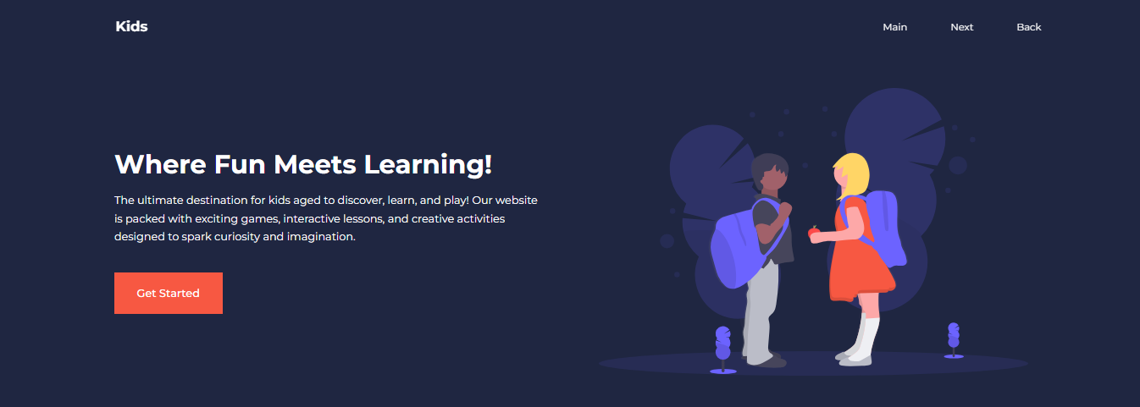

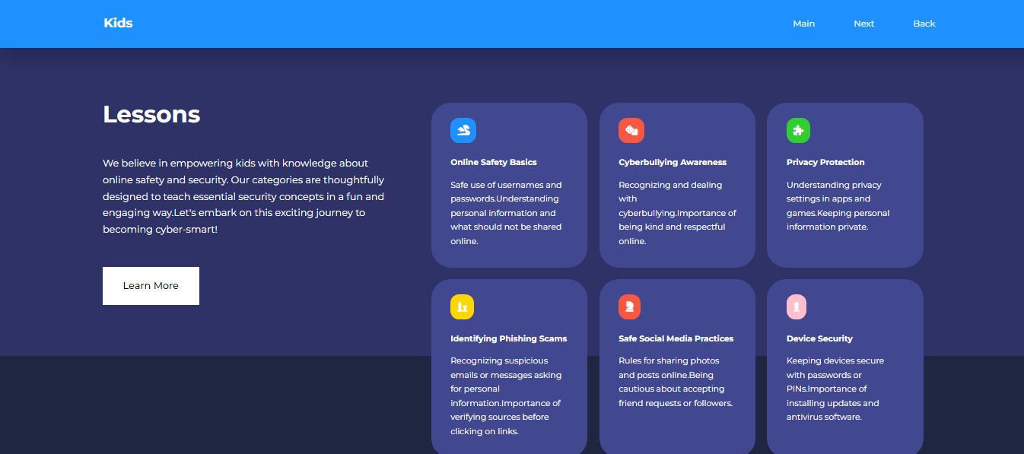

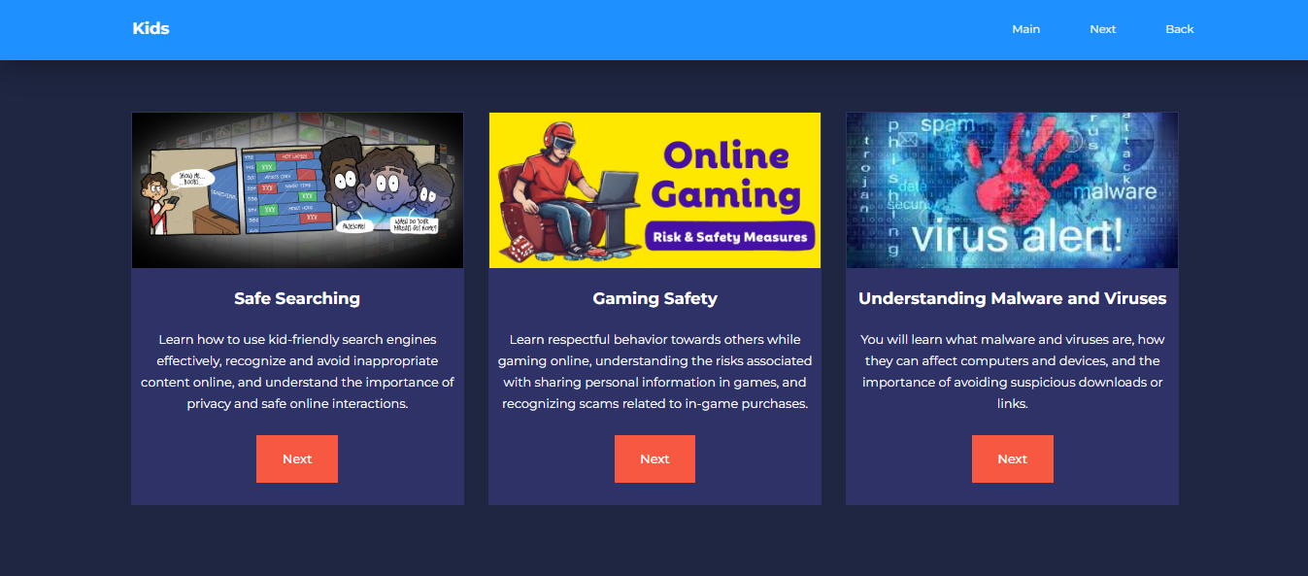

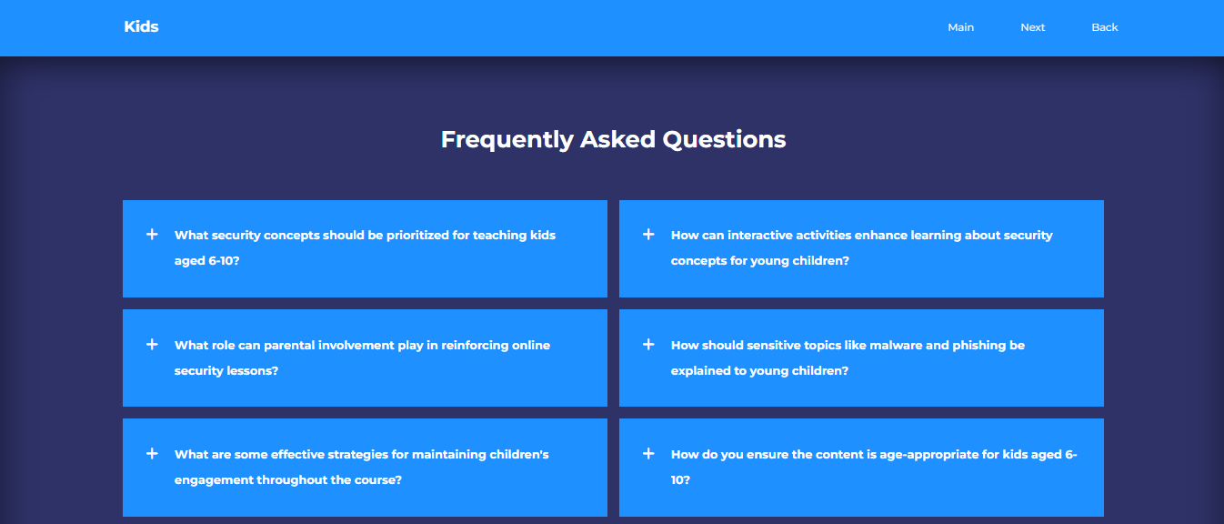

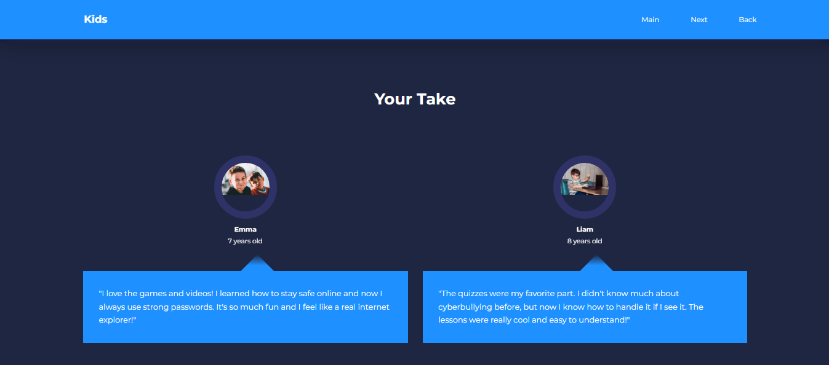



**6 Lesson Pages**

**Online Safety Page**

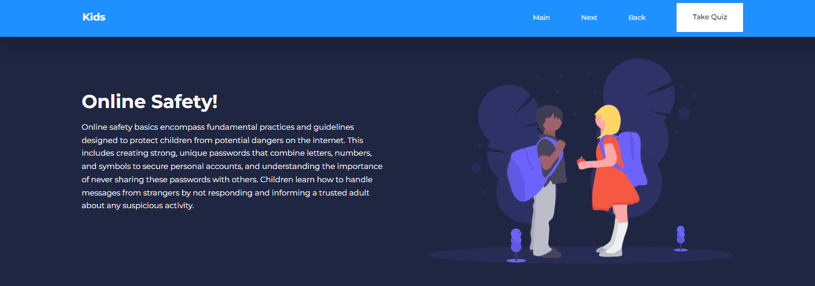

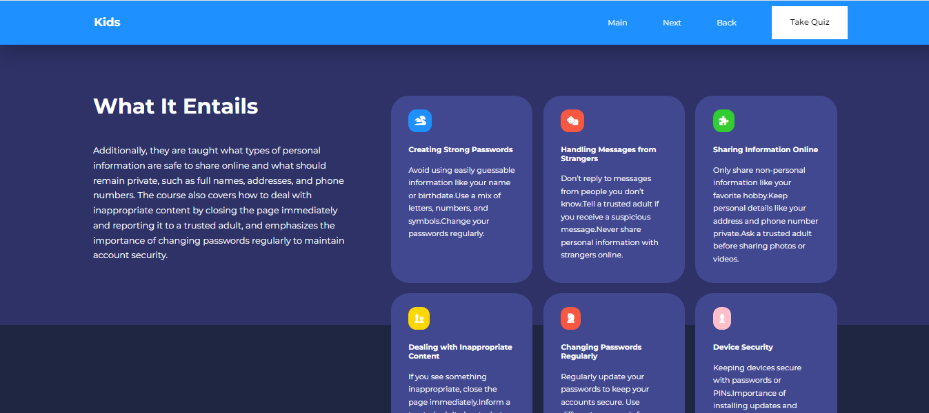

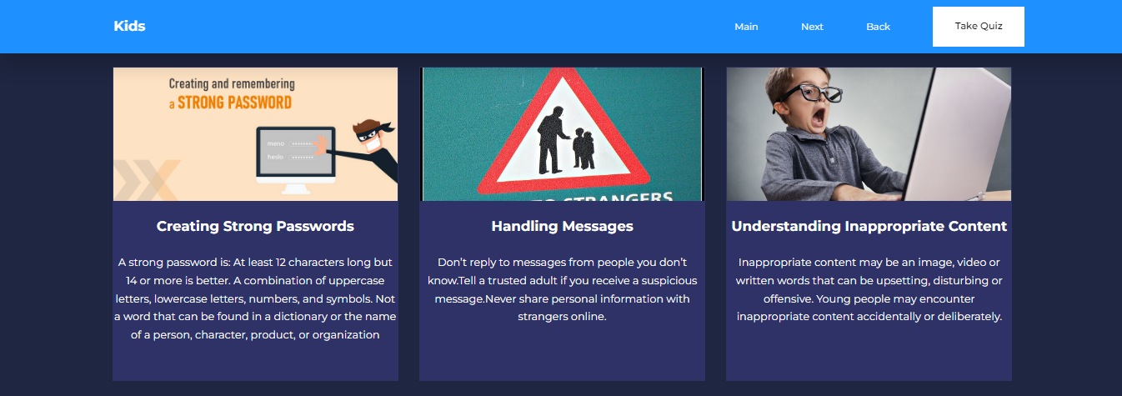

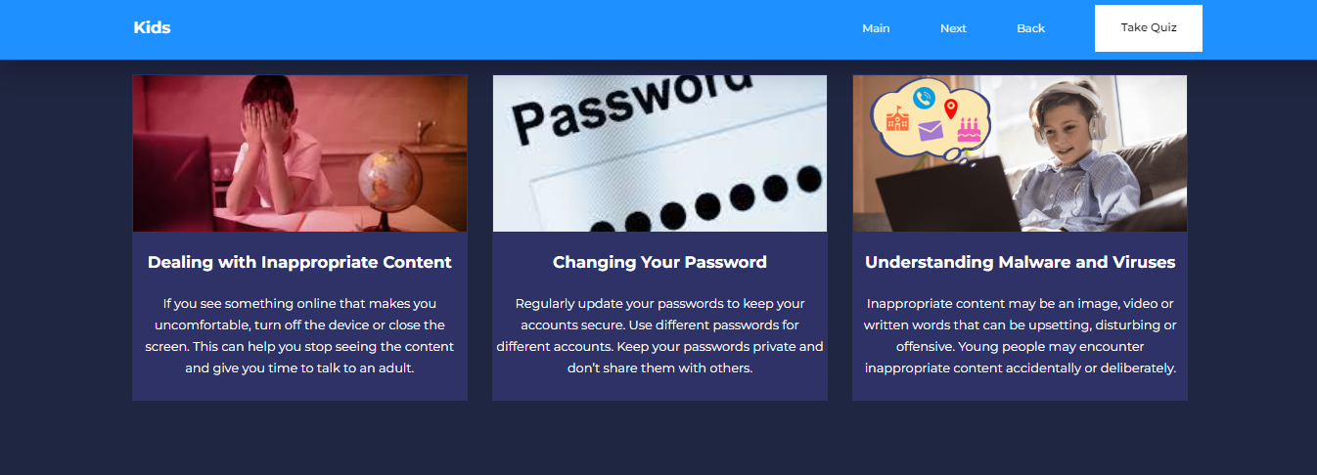

**Cyber Bullying Page**

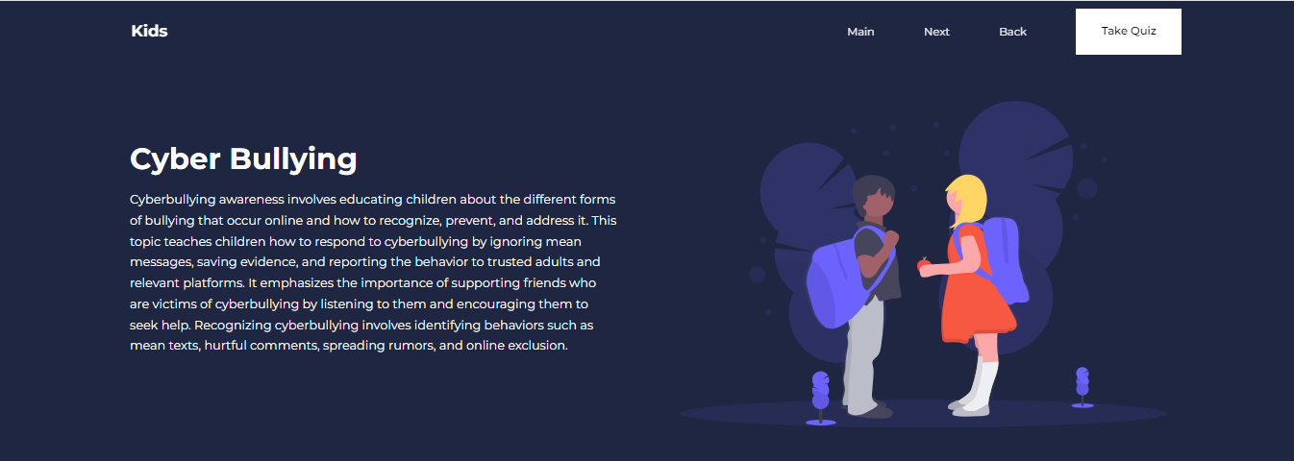

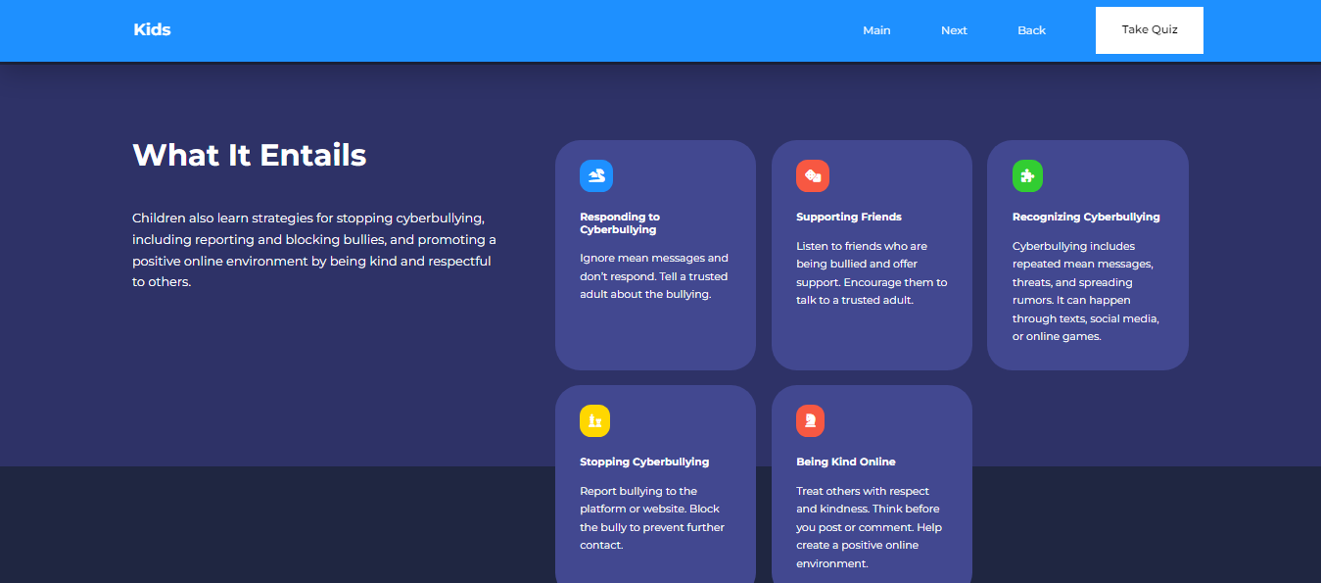

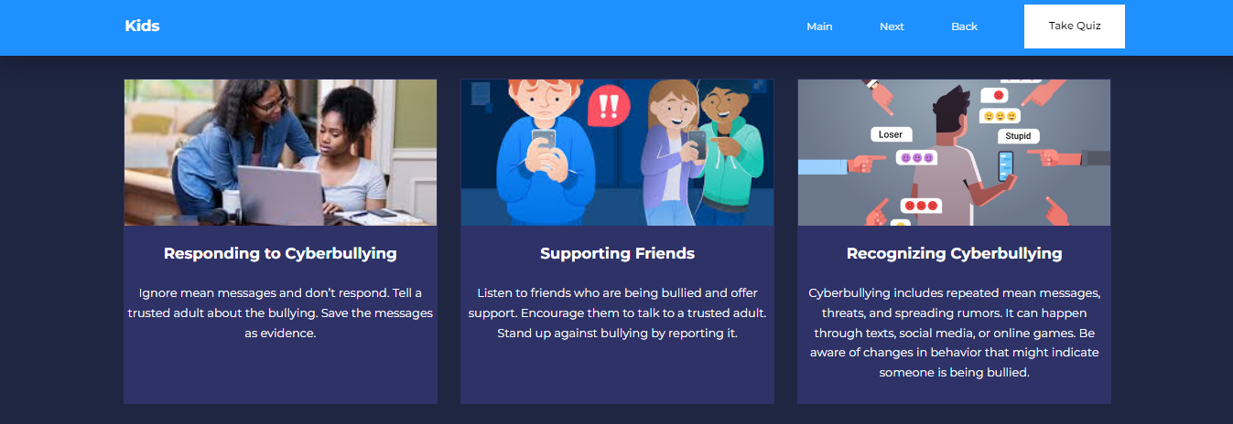

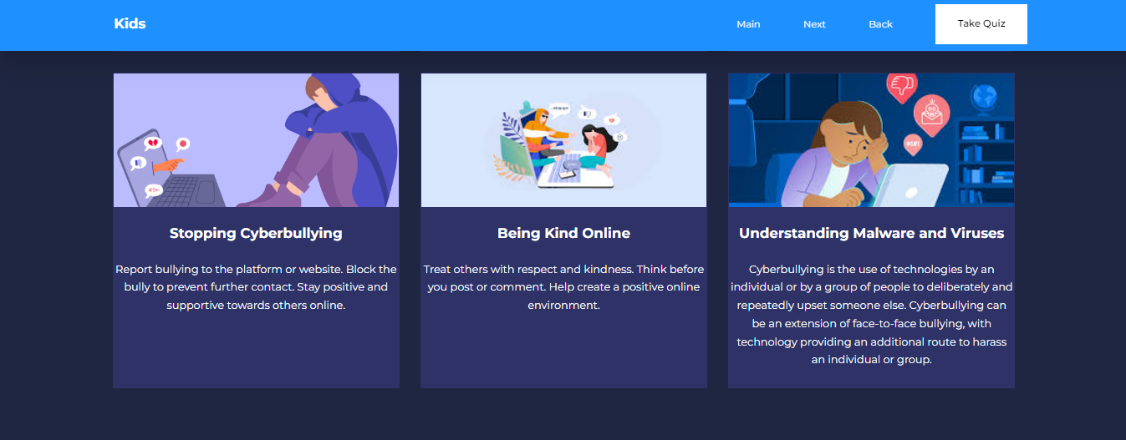

**Privacy Protection Page**

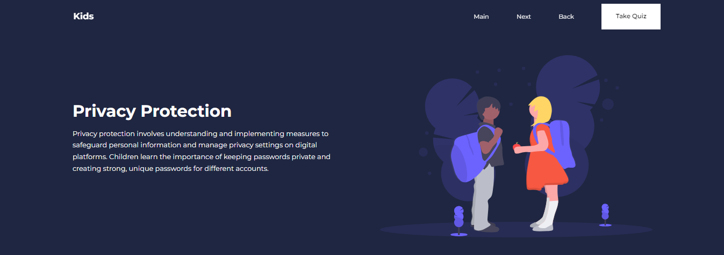

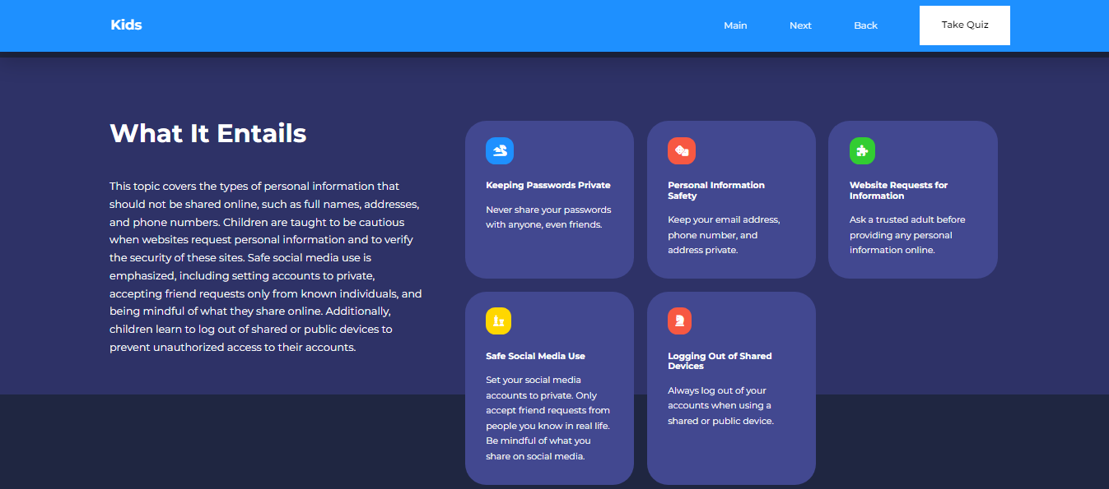

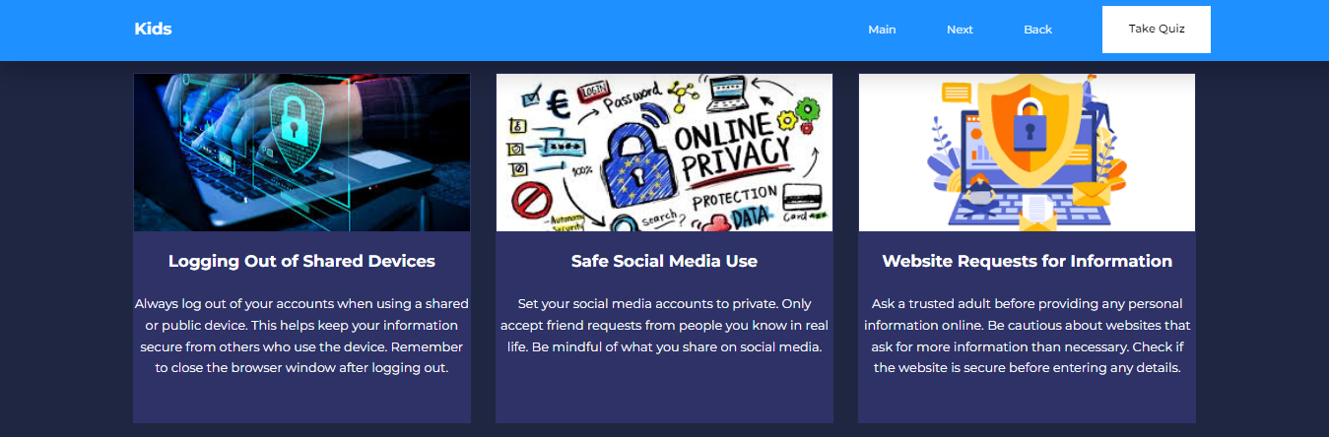

**Identifying Phishing Scams**

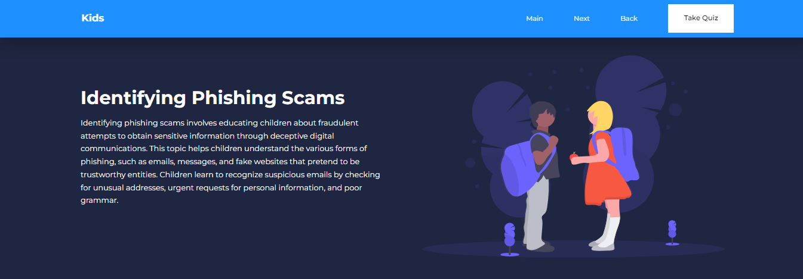

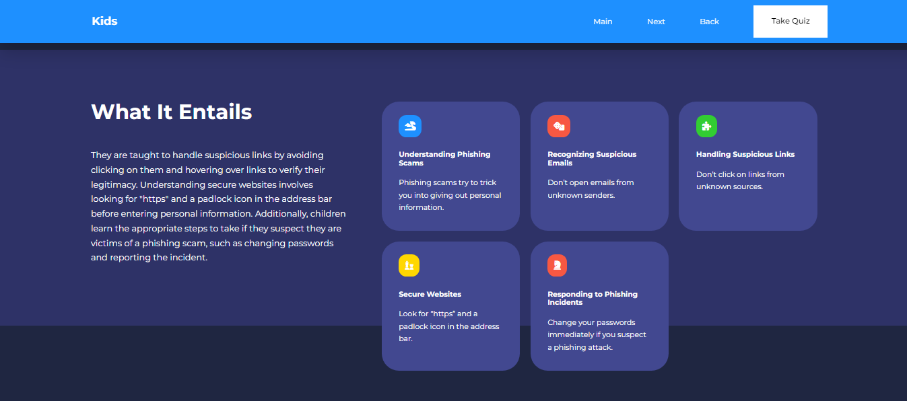

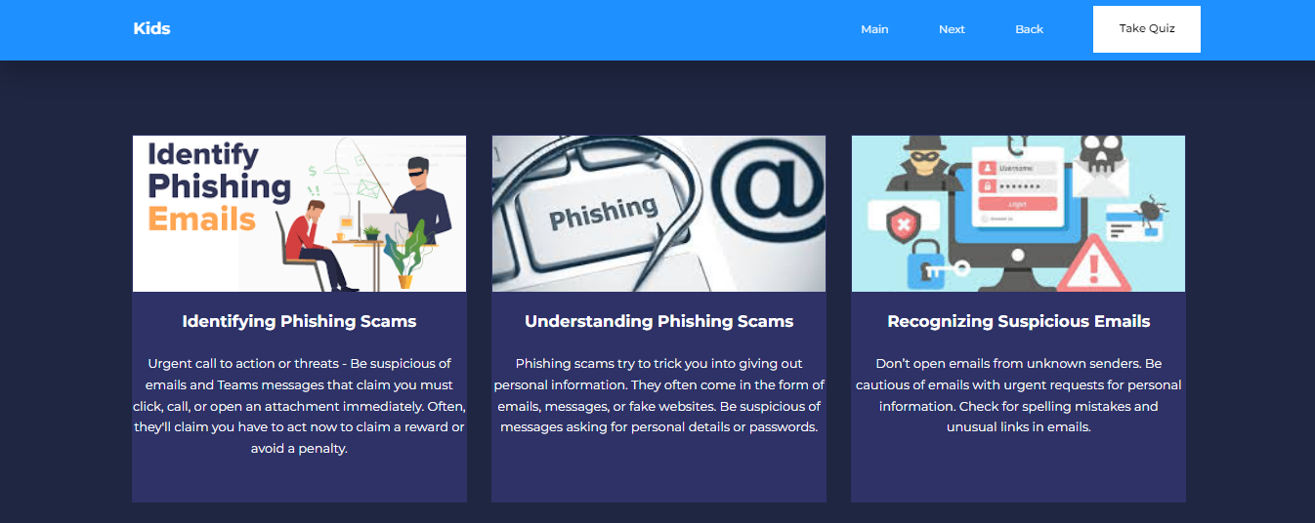

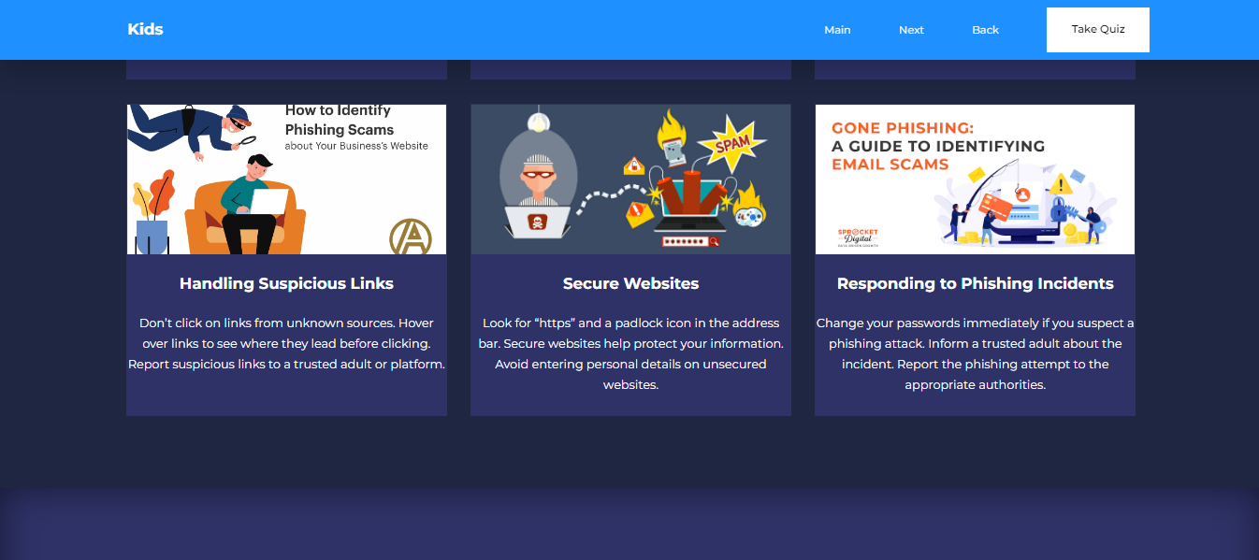

**Safe Social Media Practices**

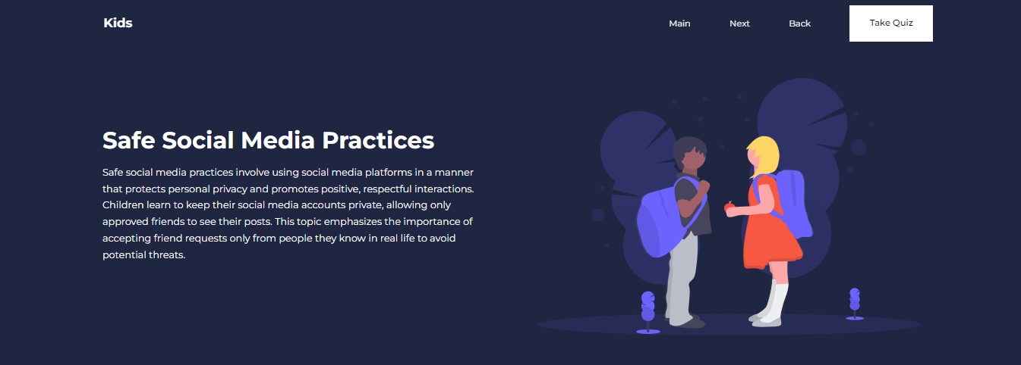

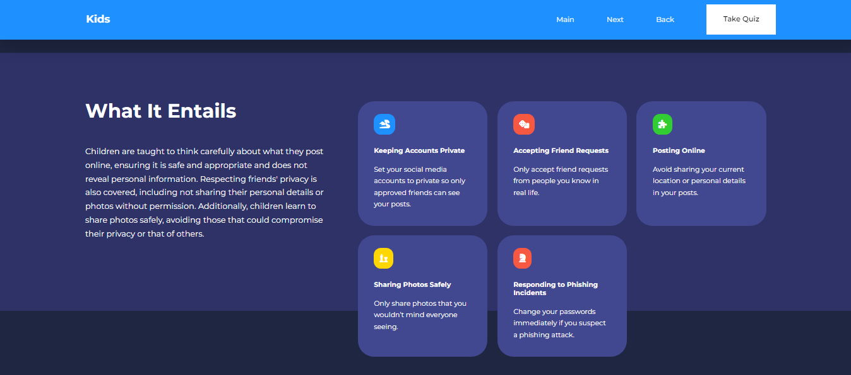

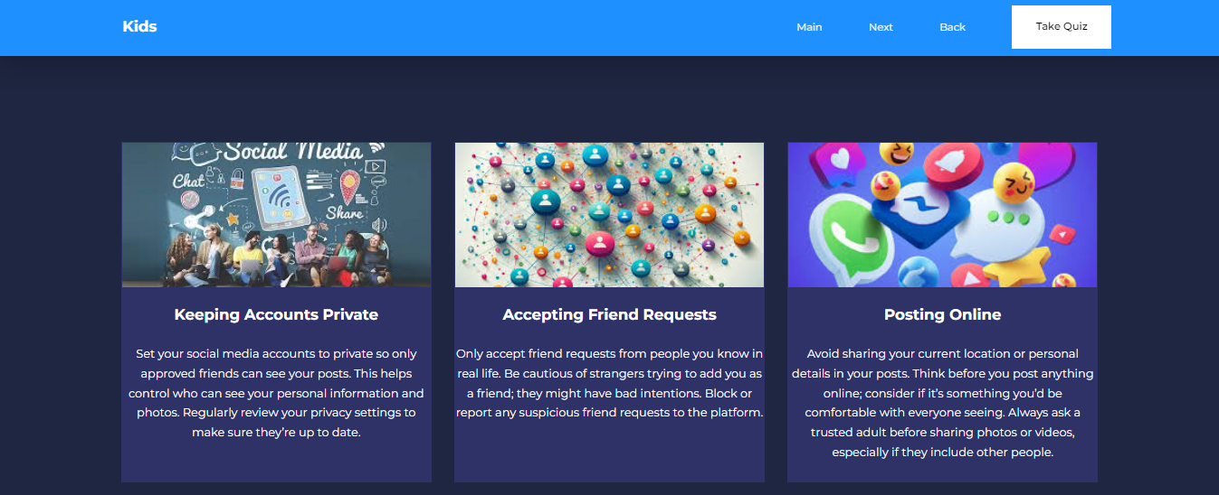

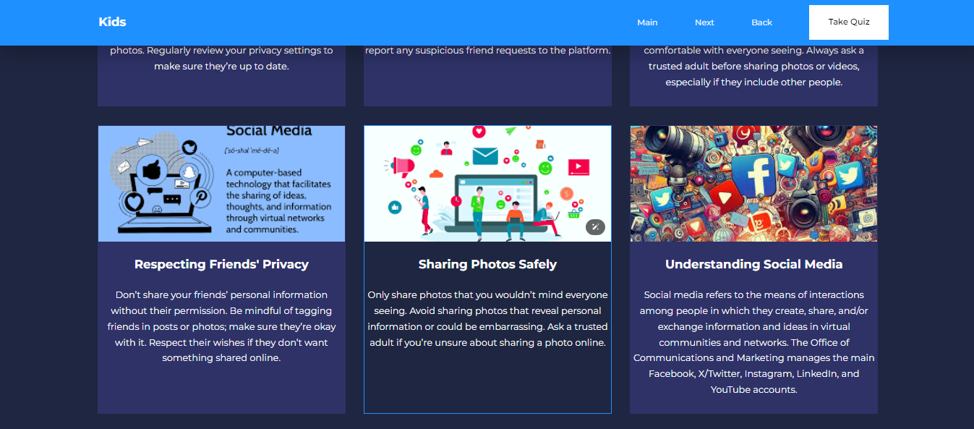

**Device Security**

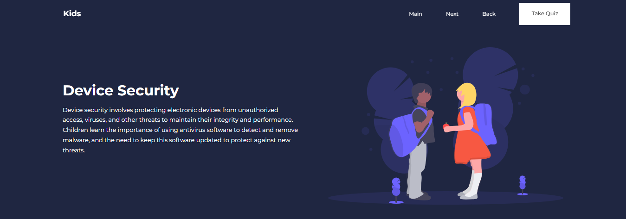

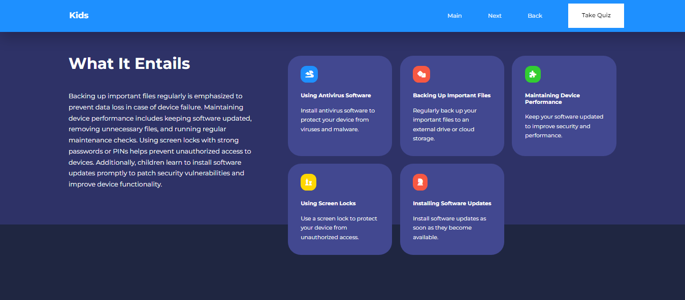

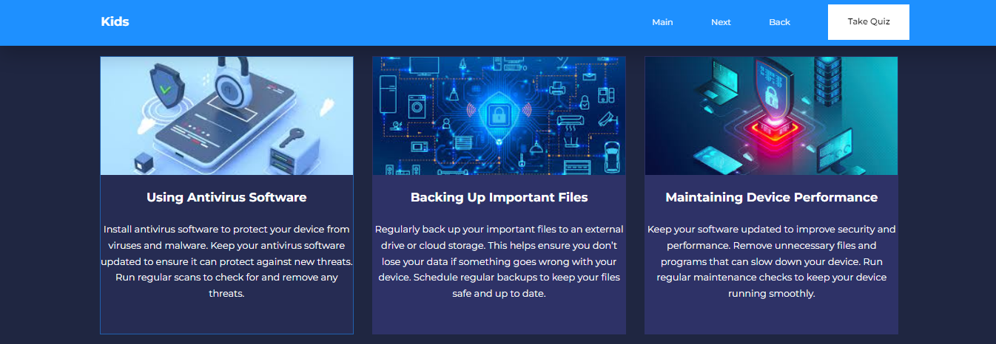

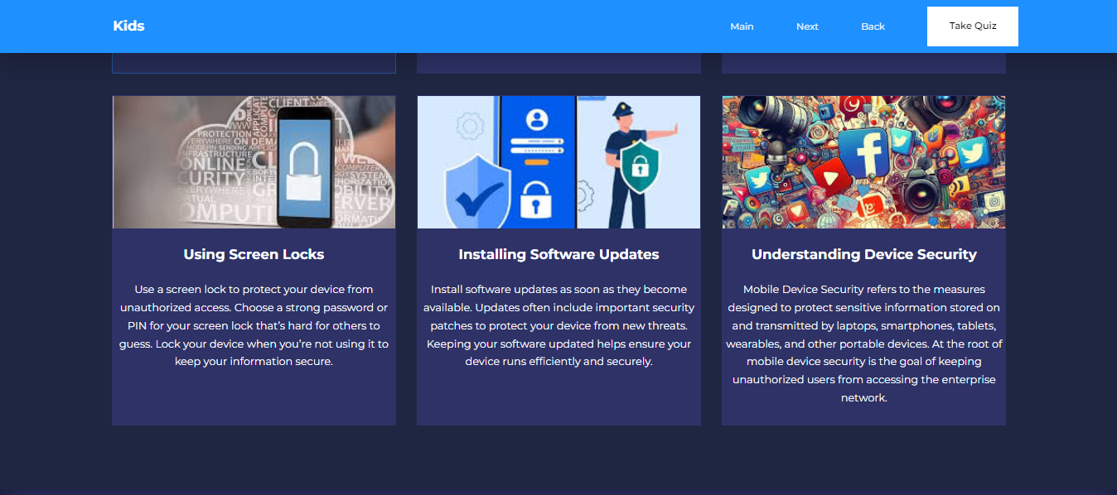

**6 Lesson Pages**

**Online Safety Quiz**

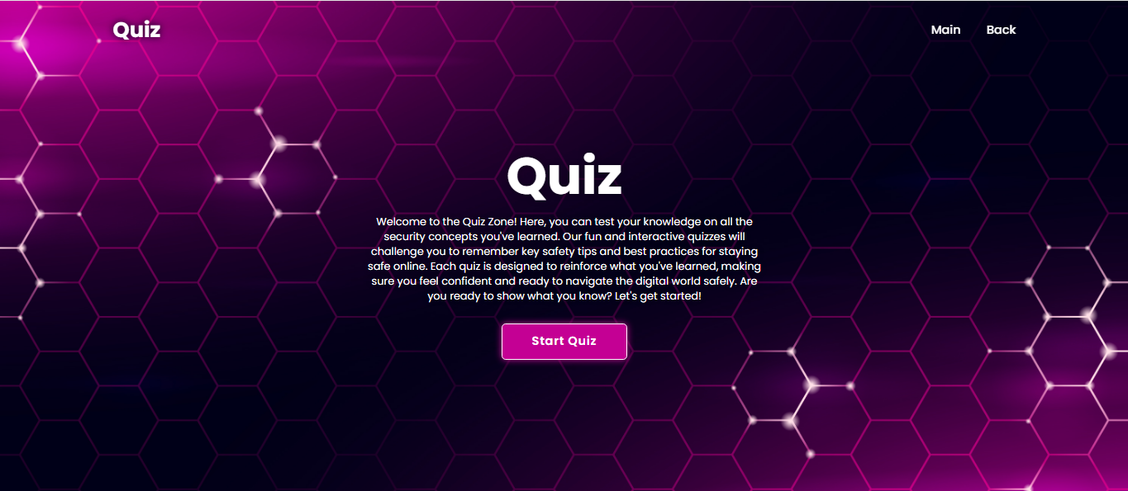

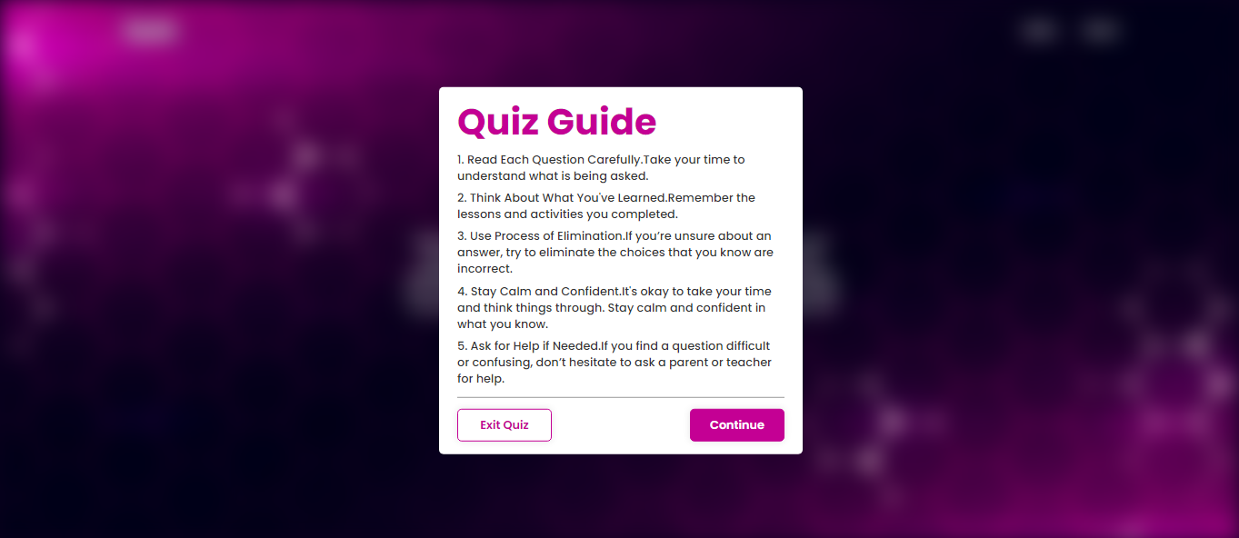

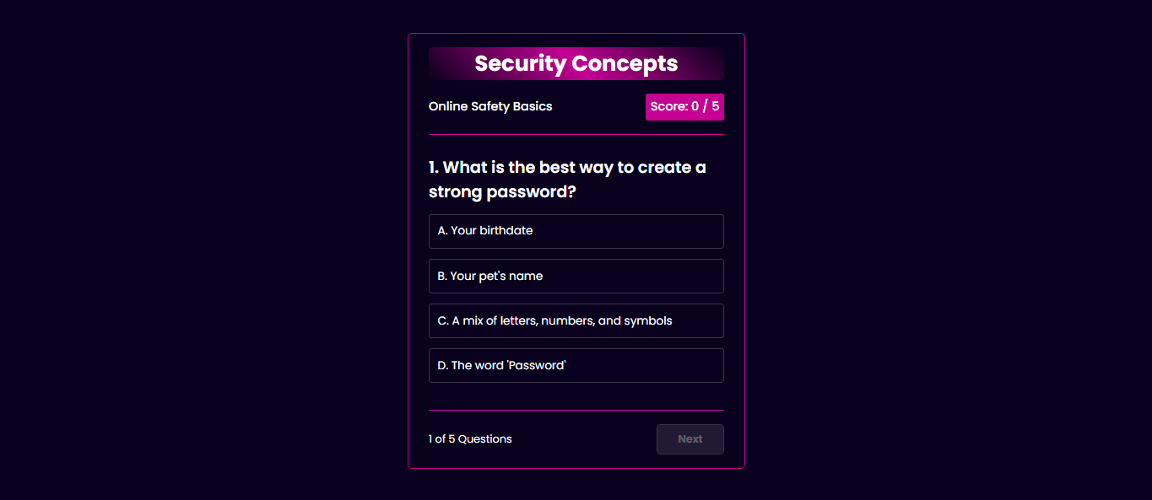

**Online Safety Result**



**Cyberbullying Result**



**Privacy Protection Result**



**Identifying Phishing Scams**



**Cyber Bullying Quiz**

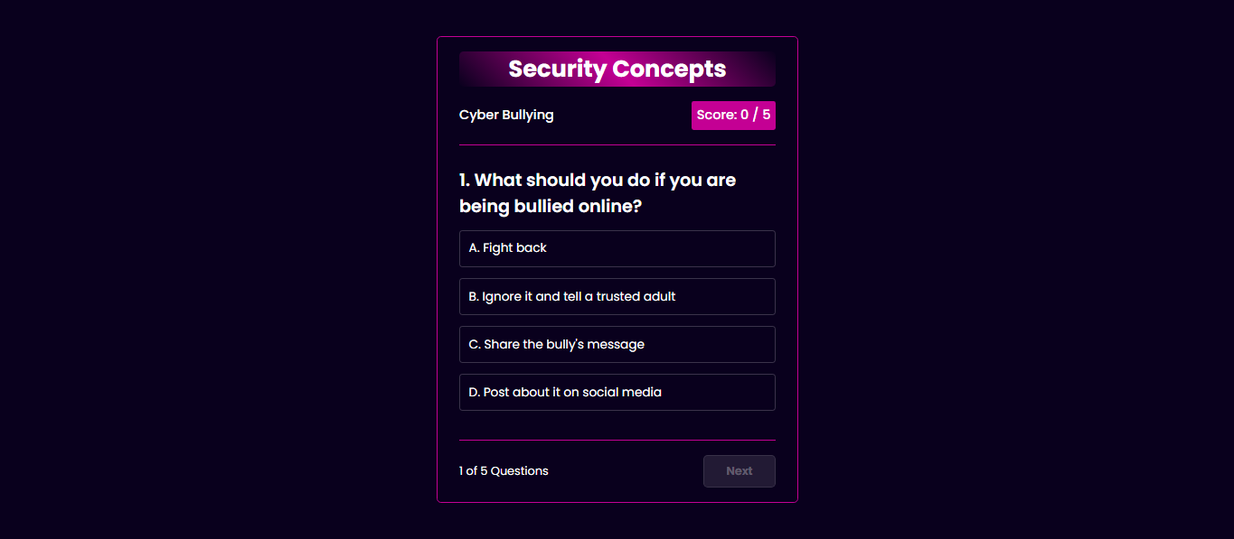

**Privacy Protection Quiz**

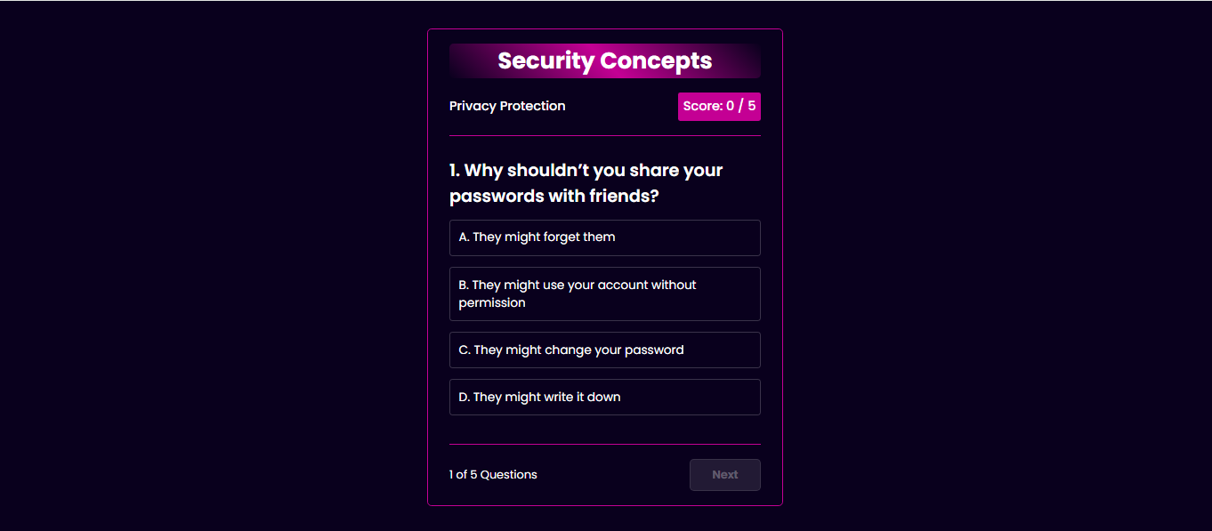

Identifying Phishing Scams

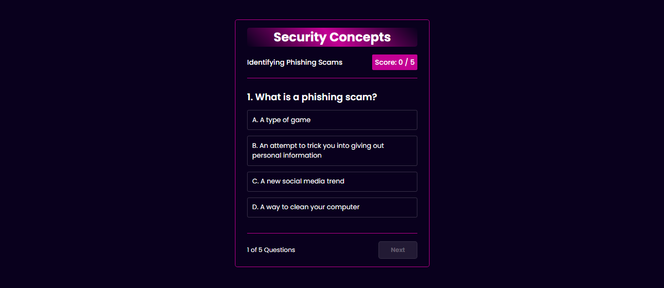

**Social Media Practices**

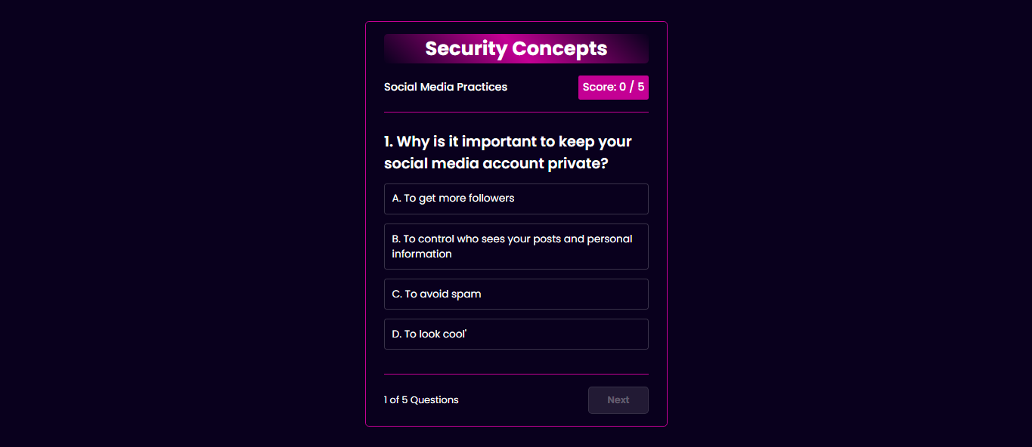

**Device Security**

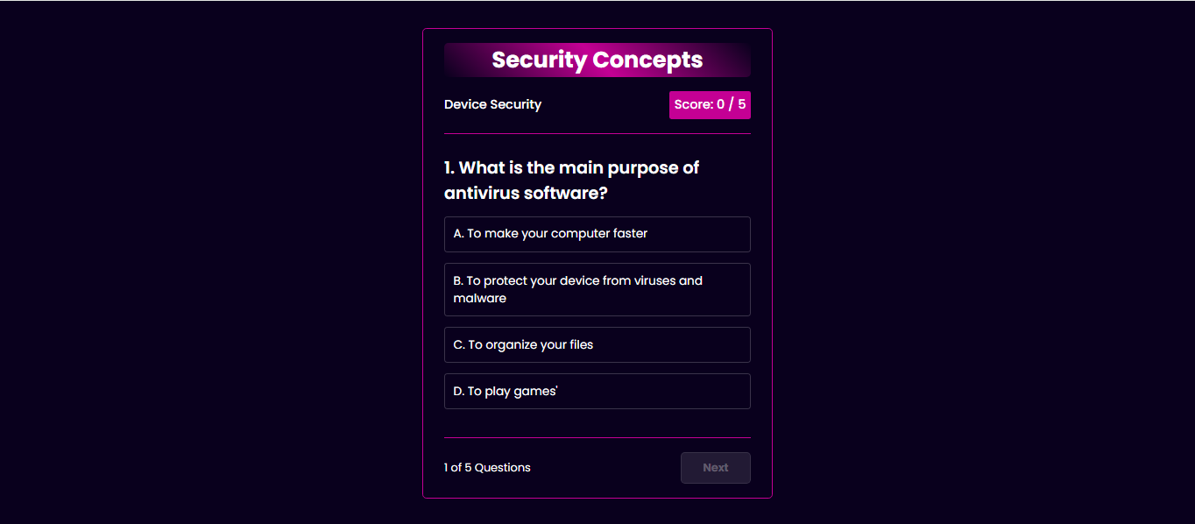

**Social Media Practices**

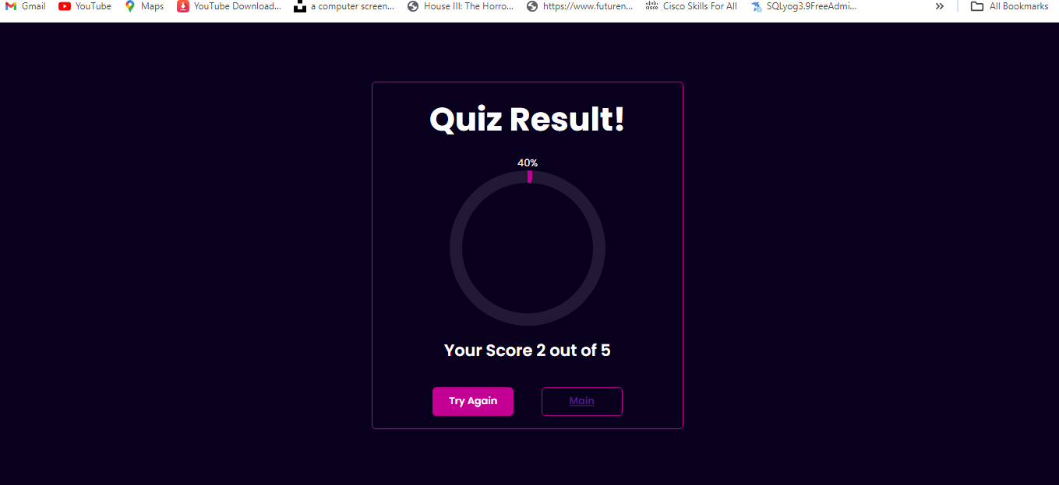

**Device Security**

